TRUE FLIX COMPUTER MAP

1. Go to the library homepage. (knoxschools.org/cartereslmc).

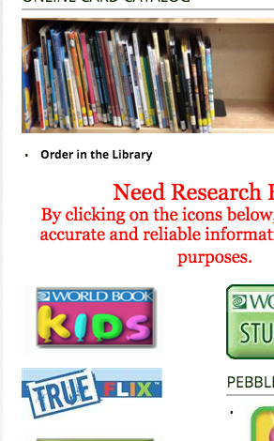

2. Click on GO. You do not need a user name or password at school. If you are at home, you can use the username and password on the password bookmark Miss Cameron gave you. See Miss Cameron if you need another bookmark.

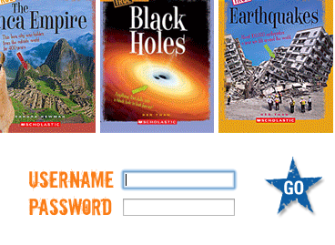

3. Scroll down until you find the topic you want to learn more about. 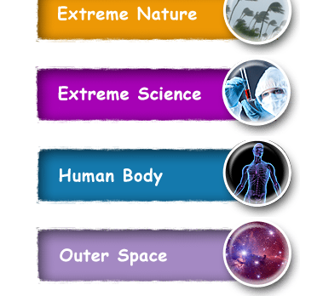

4. Click on the book you would like to read.

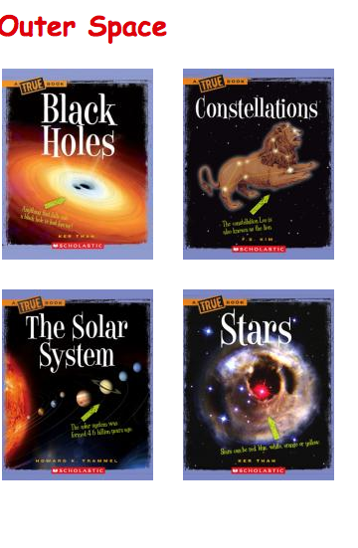

5. Click on Open to read the book or the play button that looks like an arrow inside of a circle to watch the video.

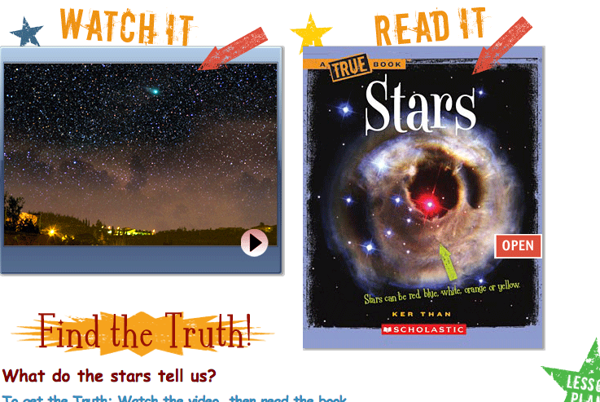

6. Click open to read the book if that’s what you chose.

